JAVASCRIPT

Js working video: https://www.youtube.com/watch?v=iLWTnMzWtj4&ab_channel=AkshaySaini

**JavaScript: Synchronous and Single-Threaded (Brief Explanation with Notes & Example)**

**✅ Brief Explanation:**

JavaScript is **synchronous** and **single-threaded**, meaning:

* It executes **one line at a time** in the order it's written (synchronously).
* It uses **one call stack**, meaning it can only handle **one task at a time** (single-threaded).

However, with **asynchronous features** (like setTimeout, Promises, etc.), JavaScript can handle tasks *without blocking* the main thread by using the **event loop** and **callback queue**.

**🧪 Example (Synchronous Execution):**

console.log("1");

console.log("2");

console.log("3");

**Output:**

CopyEdit

1

2

3

Each line runs one after the other, synchronously.

**Notes:**

* **Synchronous:** Executes code line by line, waits for the current task to finish before moving on.
* **Single-threaded:** Only one command runs at a time on the main thread.
* **Call Stack:** Keeps track of function calls.
* **Asynchronous behavior:** Achieved through browser APIs + event loop (not multithreading).

**Example (Asynchronous Behavior with setTimeout):**

console.log("A");

setTimeout(() => {

console.log("B");

}, 1000);

console.log("C");

**Output:**

A

C

B

Even though setTimeout is written second, it's delayed and handled asynchronously by the event loop.

**How javascript works**

**Global execution context**

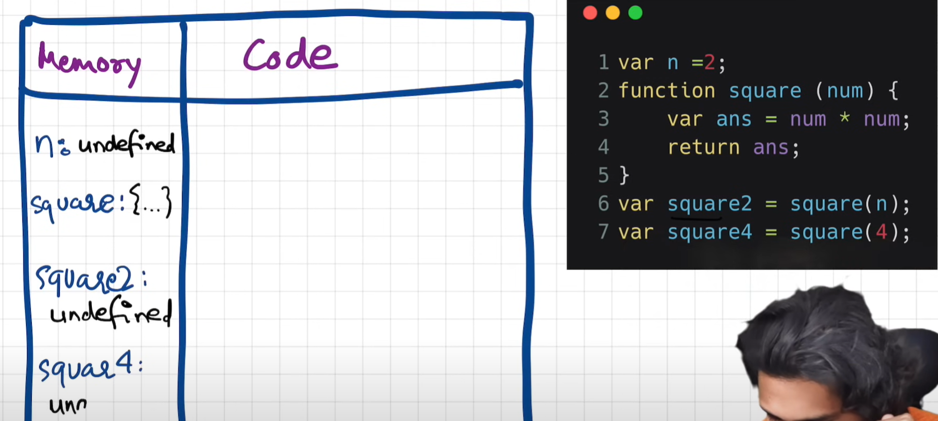

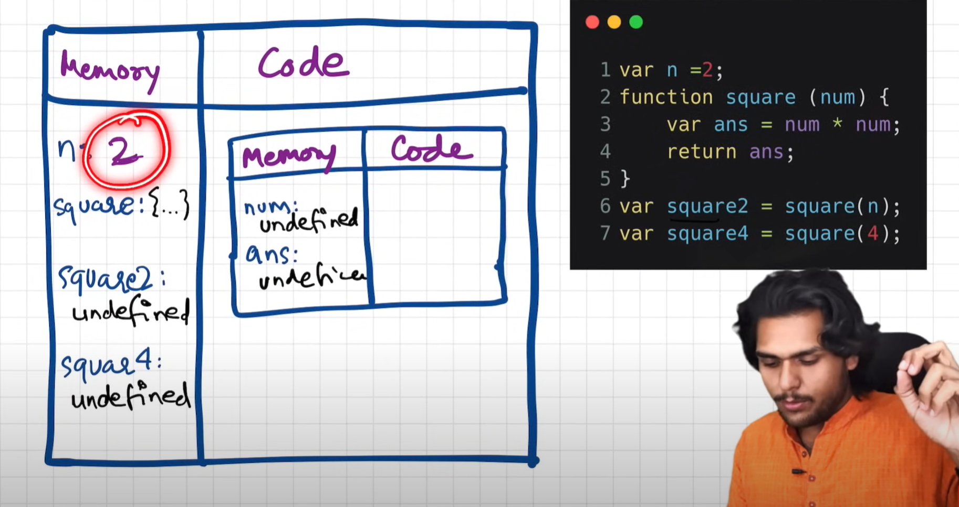

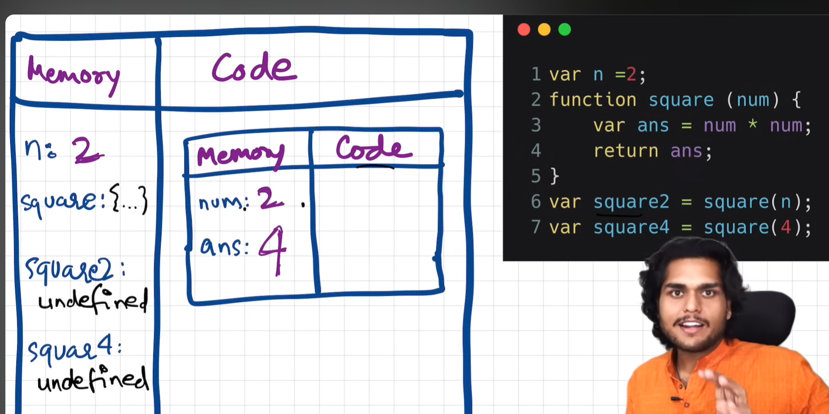

1.

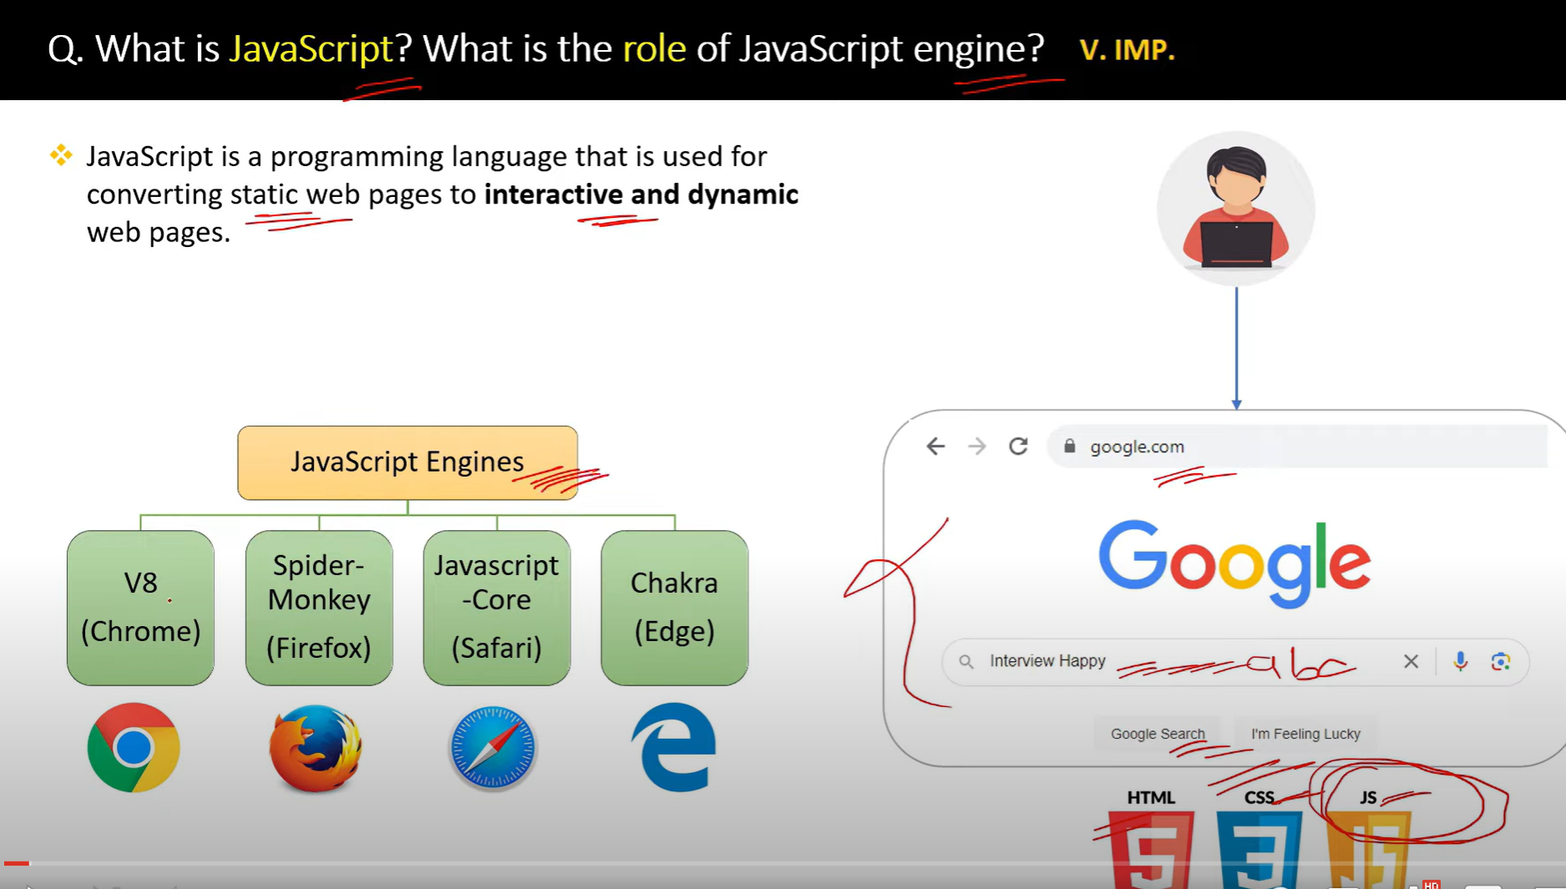

**JavaScript (JS)** is a high-level, dynamic, and interpreted programming language that is widely used to create interactive, dynamic content for websites. Originally developed to enable client-side scripting in web browsers, JavaScript has grown into a versatile language used in various environments, including web servers, mobile apps, desktop applications, and more.

**Key Characteristics of JavaScript:**

1. **Interpreted Language**:
   * JavaScript code is executed line by line by the browser's JavaScript engine, without needing to be compiled.
2. **Client-Side Scripting**:
   * JavaScript primarily runs in the browser to enhance user interaction. It allows developers to manipulate web content, handle events, validate user input, and create interactive websites.
3. **Event-Driven**:
   * JavaScript allows handling events such as user clicks, form submissions, or keyboard inputs, making websites responsive and interactive.
4. **Lightweight and Fast**:
   * JavaScript is lightweight and designed to work quickly, providing instant responses to user actions.
5. **Dynamic Typing**:
   * Variables in JavaScript are not explicitly typed. The same variable can hold different types of values at different times (e.g., numbers, strings, or objects).
6. **Object-Oriented Programming (OOP)**:
   * While JavaScript uses prototypes instead of traditional class-based inheritance, it still supports object-oriented programming principles like encapsulation, inheritance, and polymorphism.
7. **Multi-paradigm**:
   * JavaScript supports various programming paradigms, including imperative (procedural), object-oriented, and functional programming.
8. **Runs Everywhere**:
   * JavaScript can be used both on the client side (in the browser) and on the server side (with

2.

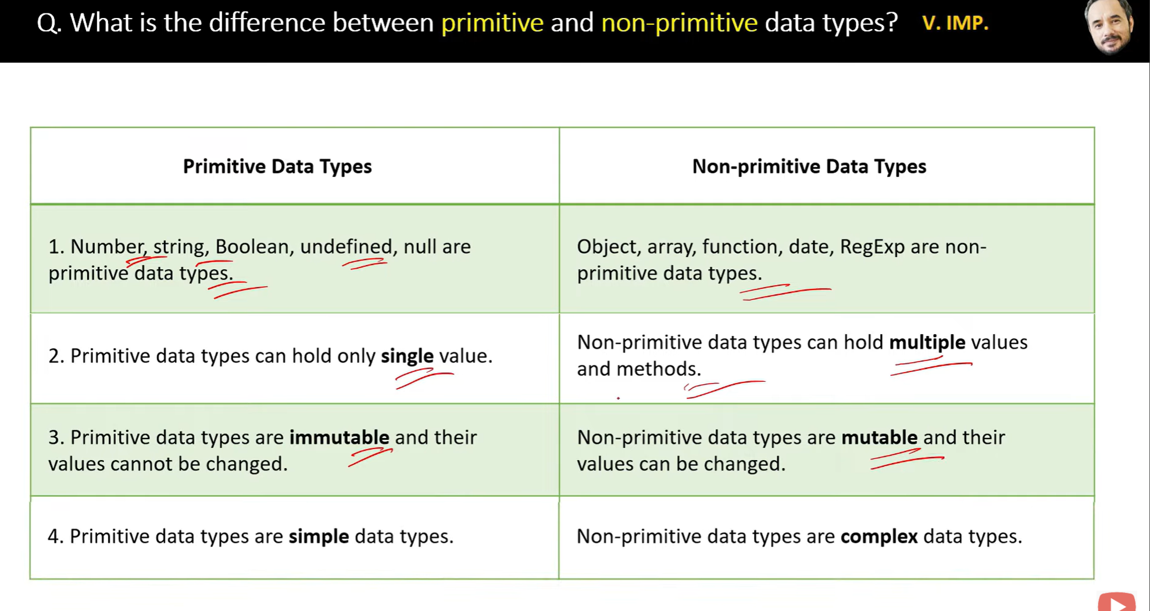

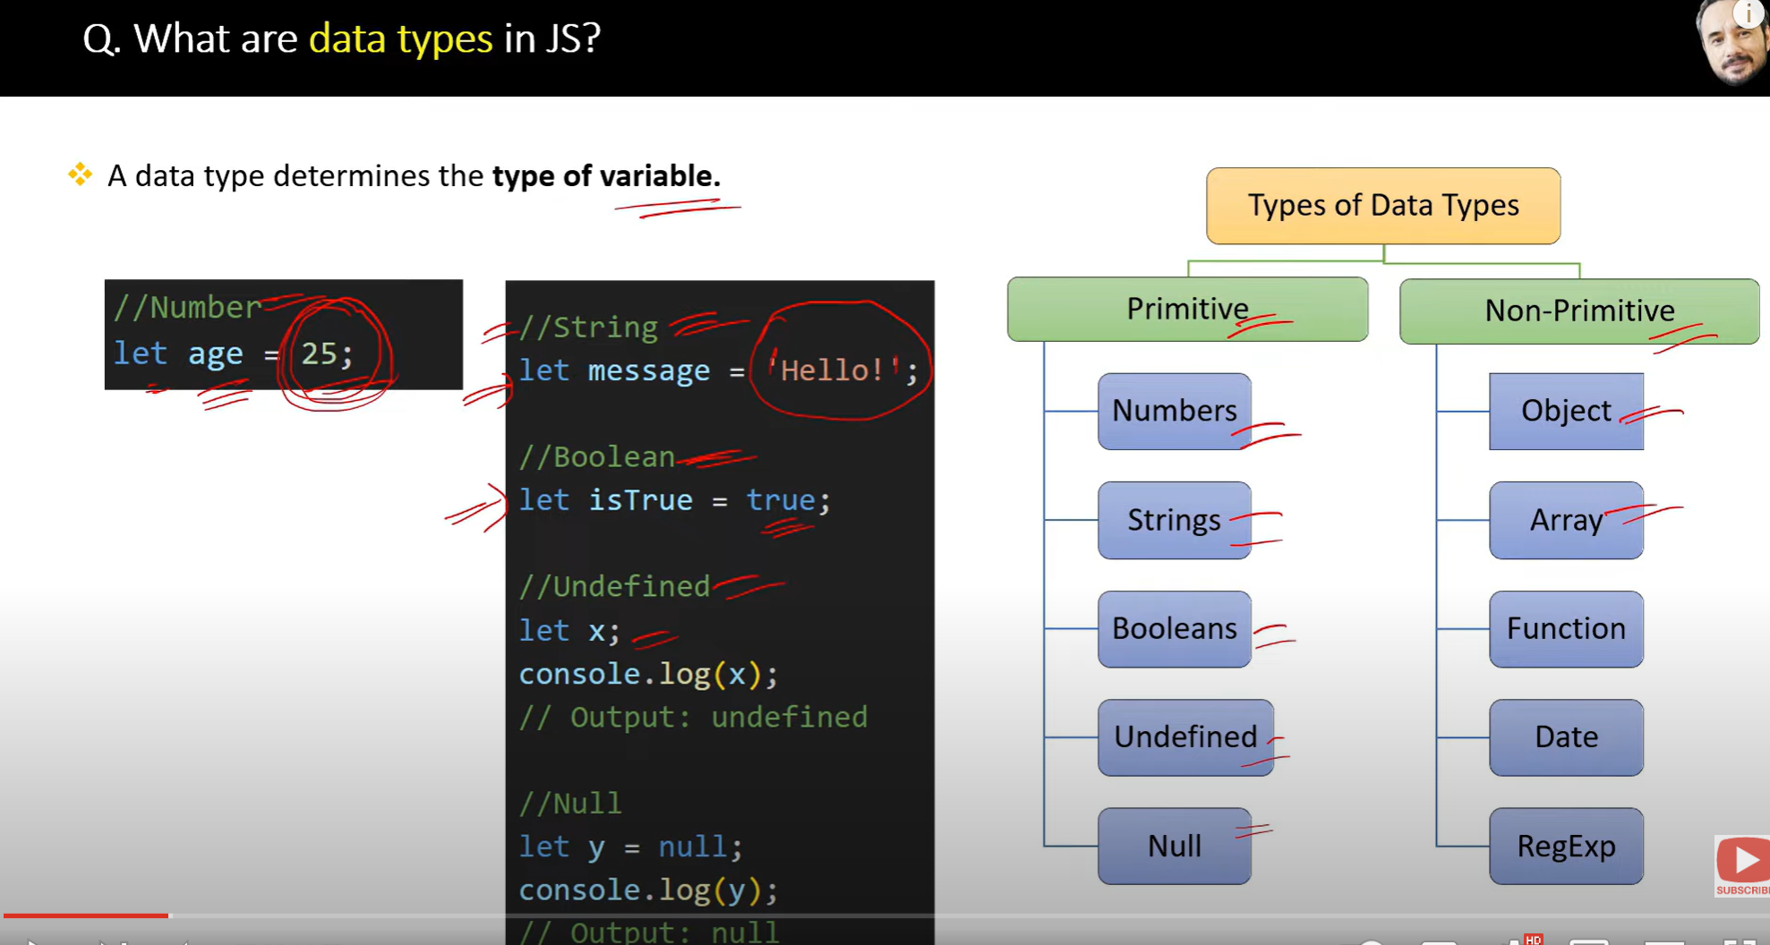

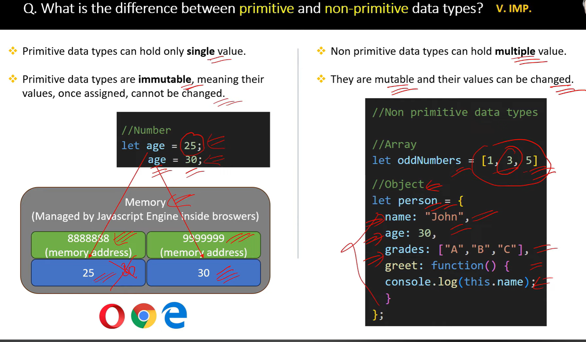

A **mutable** object or variable can be modified after it is created.

An **immutable** object or variable cannot be modified after it is created.

3.

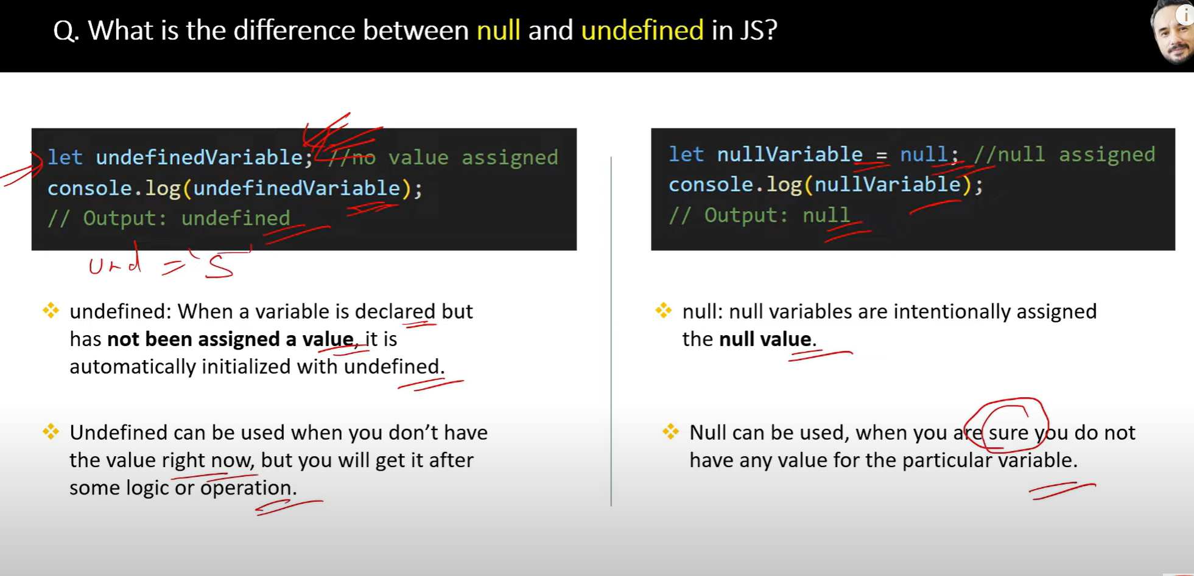

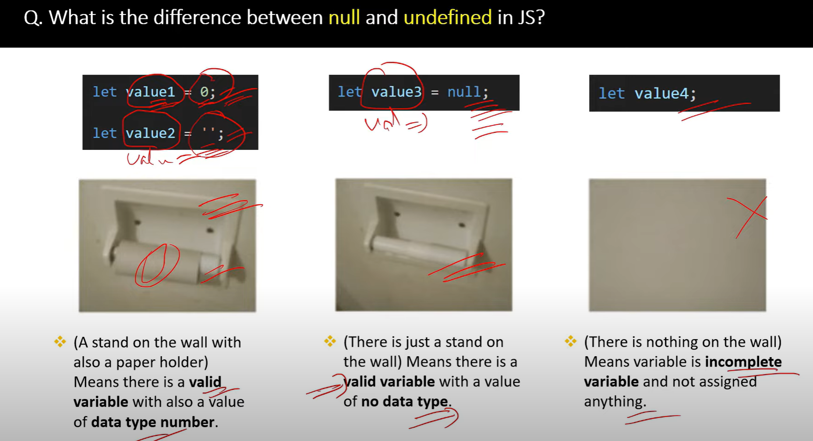

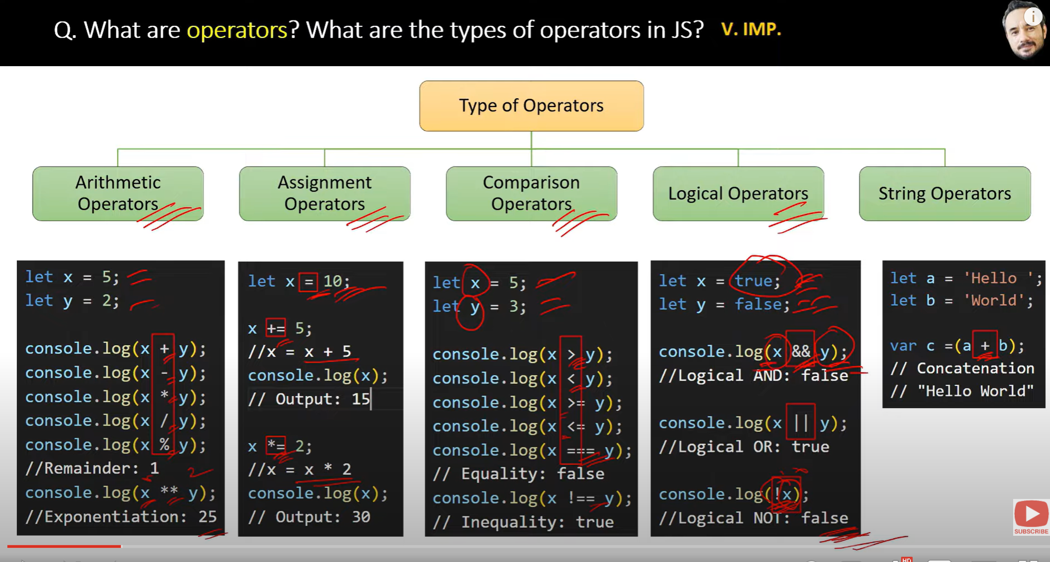

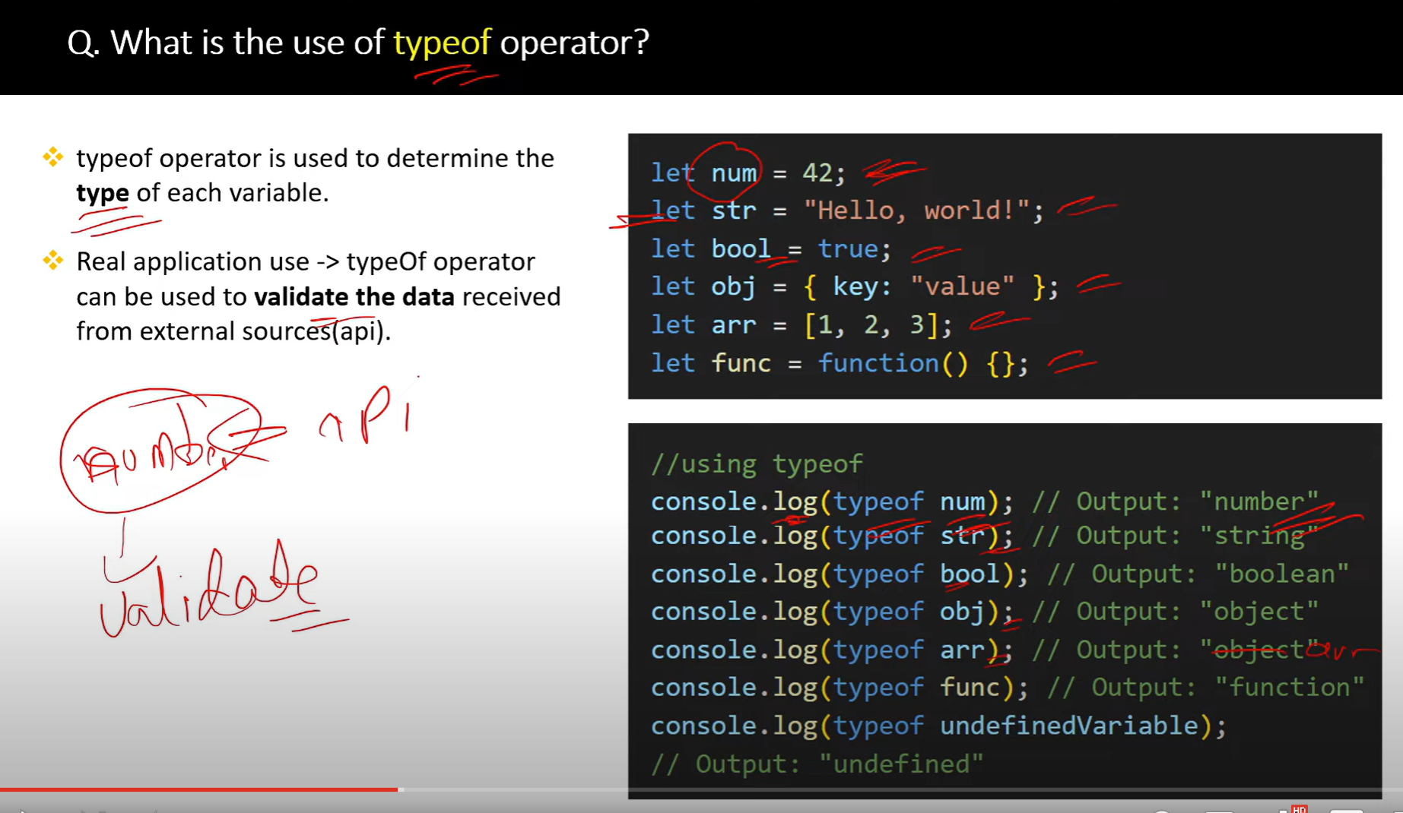

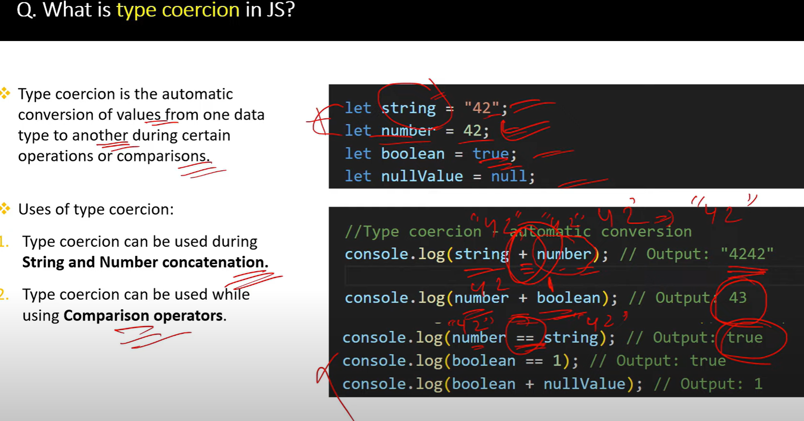

**True** is considered as **1**

**False** is considered as **0**

/*

Type Coercion Interview Questions and Examples

Q1: What is type coercion in JavaScript?

A: Type coercion is the automatic conversion of values from one data type to another when performing operations.

There are two types of coercion:

<!-- - Implicit (automatic): When JavaScript automatically converts the data type of a value to another data type. For example, when a string is concatenated with a number, the number is implicitly coerced to a string.

- Explicit (manual): When the developer explicitly converts the data type of a value to another data type. For example, using the Number() function to convert a string to a number. -->

Examples:

*/

// 1. String Coercion

console.log("1" + 2); // "12"

console.log(1 + "2"); // "12"

console.log(1 + 2 + "3"); // "33" - 1+2 is calculated first, then concatenated with "3"

// 2. Numeric Coercion

console.log("3" - 2); // 1

console.log("5" * 2); // 10

console.log("10" / 2); // 5

/*

Q2: What's the difference between == and === operators?

A: == performs type coercion before comparison, while === does not perform type coercion

*/

console.log(5 == "5");   // true - type coercion happens

console.log(5 === "5");  // false - no type coercion

/*

Q3: What are truthy and falsy values in JavaScript?

A: When non-boolean values are coerced to boolean, they become either true (truthy) or false (falsy)

*/

// Falsy values:

console.log(Boolean(false));     // false

console.log(Boolean(0));         // false

console.log(Boolean(""));        // false

console.log(Boolean(null));      // false

console.log(Boolean(undefined)); // false

console.log(Boolean(NaN));       // false

// Truthy values:

console.log(Boolean(true));      // true

console.log(Boolean(1));         // true

console.log(Boolean("hello"));   // true

console.log(Boolean([]));        // true

console.log(Boolean({}));        // true

/*

Q4: How does JavaScript coerce values in logical operations?

A: In logical operations, values are coerced to boolean

*/

console.log("hello" && 0);     // 0 (returns last falsy value or last value)

console.log("hello" || 0);     // "hello" (returns first truthy value)

console.log(!!"hello");        // true (double negation coerces to boolean)

/*

Q5: What happens when we add arrays or objects?

A: Arrays are converted to strings before addition, objects are converted to primitives

*/

console.log([] + []);         // "" (empty string) false, because each [] creates a new array in a different memory location.

console.log([1,2] + [3,4]);   // "1,23,4" In JavaScript, when you use the + operator with **arrays**, it **coerces them into strings**.

- This code concatenates two arrays into a string. The arrays are first converted to strings using their toString() method, resulting in "1,2" and "3,4". Then, these strings are concatenated using the + operator, resulting in "1,23,4".

console.log({} + []);         // "[object Object]"

**📒 How it works:**

1. ({}).toString() → "[object Object]"
2. [] → coerces to empty string ""
3. "[object Object]" + "" → "[object Object]"

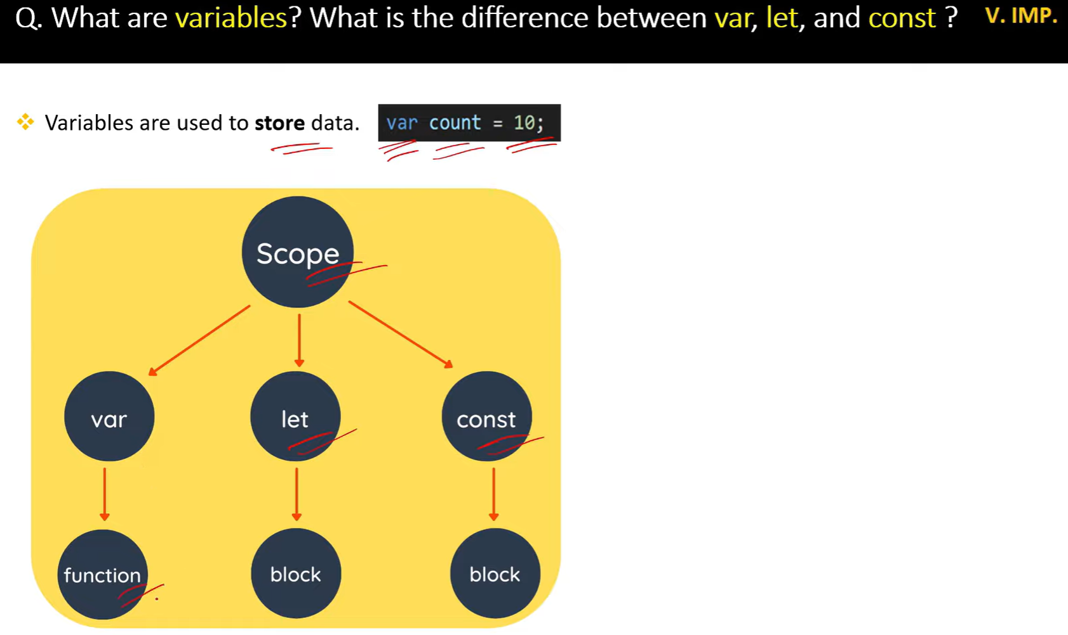

//===========================scope ========================

var  // functional scope

let and const //block scope

// global scope

Functional scope

var x = 10;

if (true) {

var x = 20;

}

console.log(x); 20

let b= 10

function Test (){

    var a= 5

    console.log(a) // 5x

    console.log(b) // 10

}

console.log(a)  //a is not defined

// block scope

let y = 10;

if (true) {

let y = 20;

}

console.log(y); // 10

{

 var a =5;

 const b =10;

    console.log(a) //5

    console.log(b) //10

}

console.log(a) //5

console.log(b) //b is not defined error

//====================variable shadowing=================

function Test(){

    let a= "Hello"

    if(true){

        let a="Hi"

        console.log(a) //Hi

    }

    console.log(a) //Hello

}

Test()

//=====================Illegal shadowing============

function test() {

    var a = "Hello";

    let b = "Bye";

    if (true) {

    let a = "Hi";

    var b = "Goodbye";

    console.log(a);   // Hi

    console.log(b);  //Identifier 'b' has already been declared

    }

    }

    test();

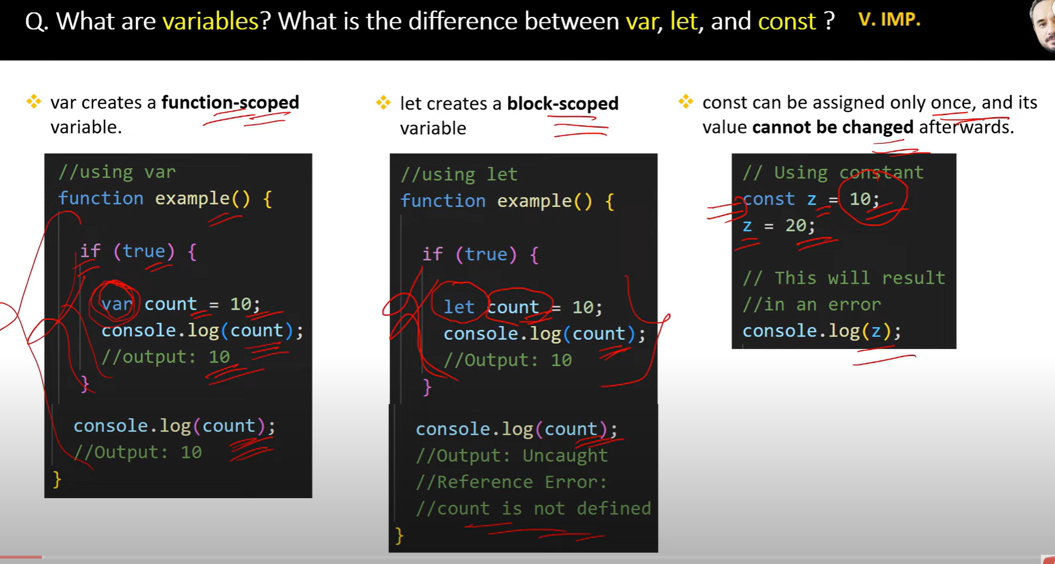

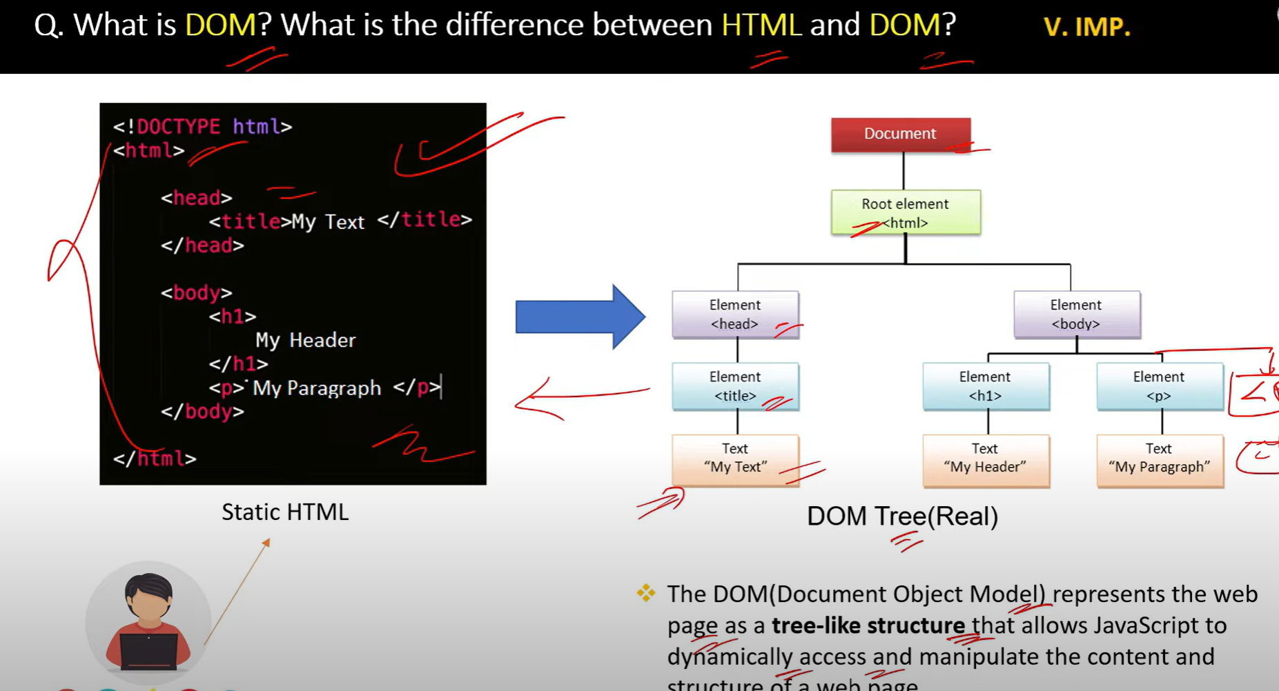

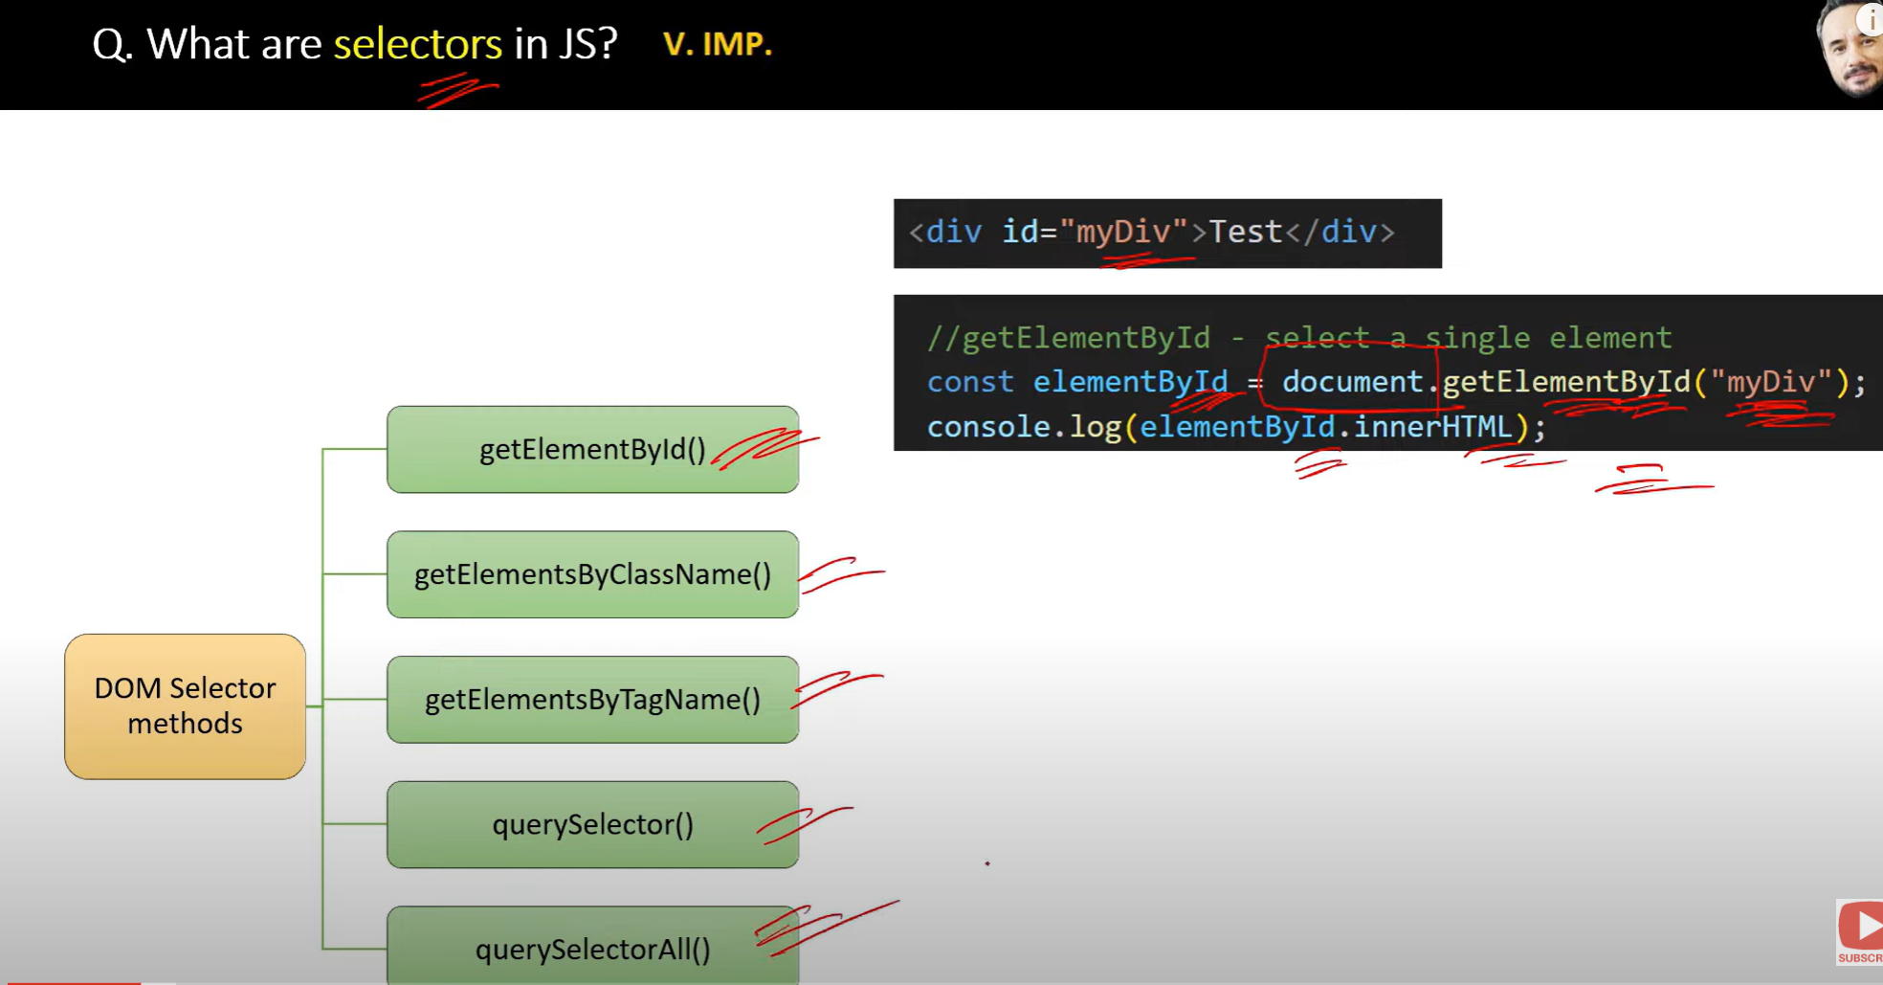

**selectors** refer to ways of selecting or accessing elements from the **Document Object Model (DOM)**, allowing developers to manipulate and interact with those elements

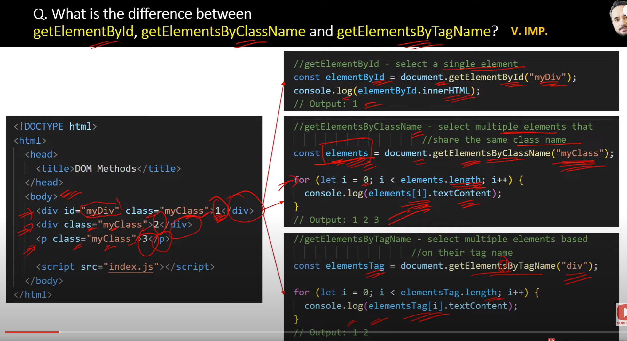

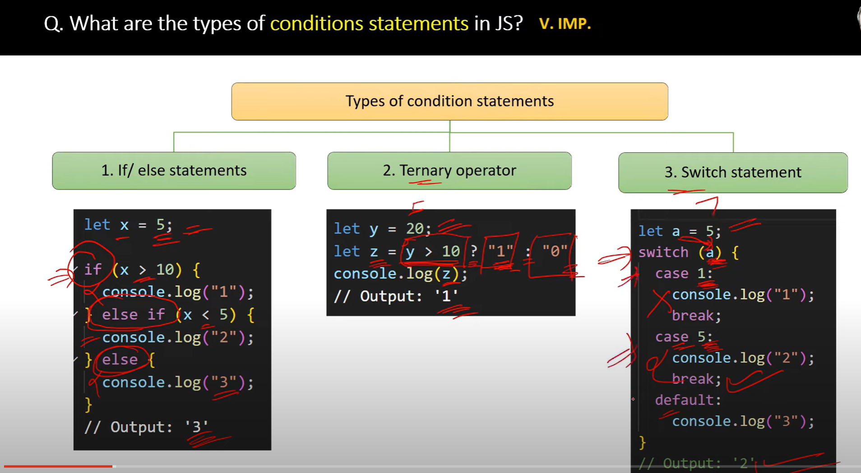

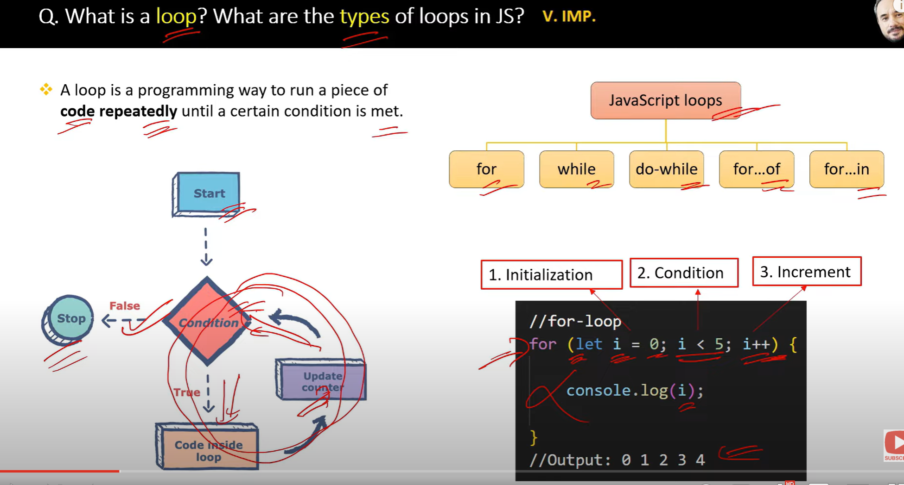

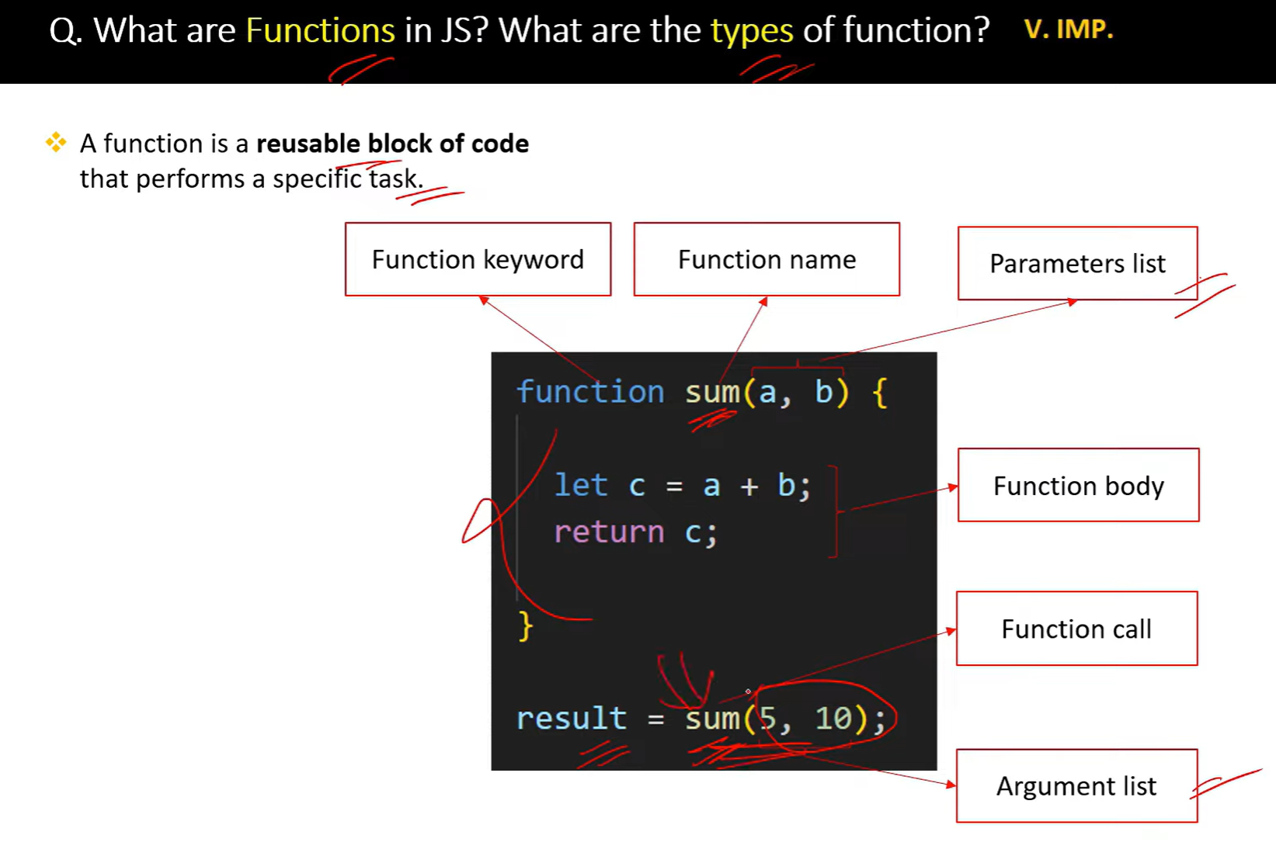

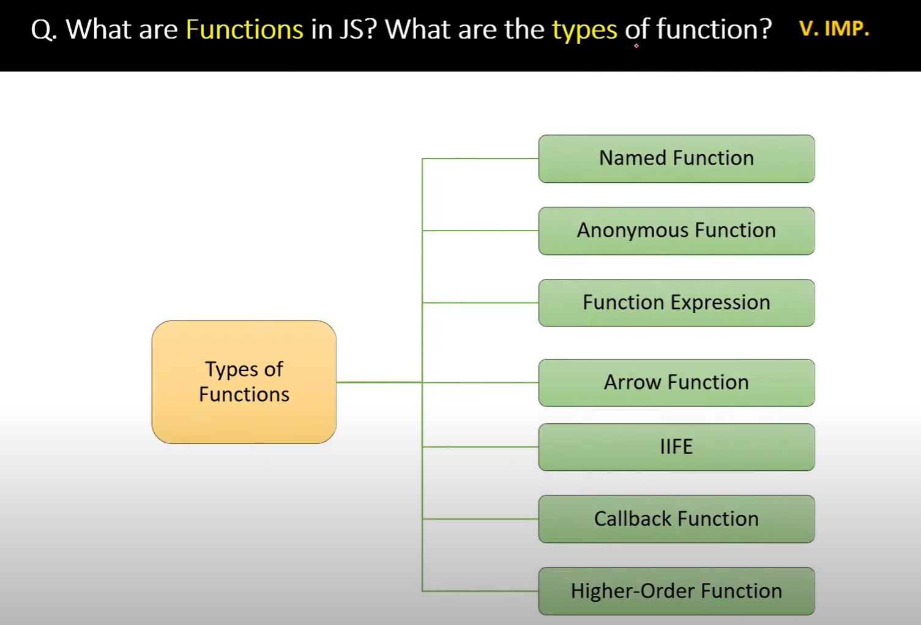

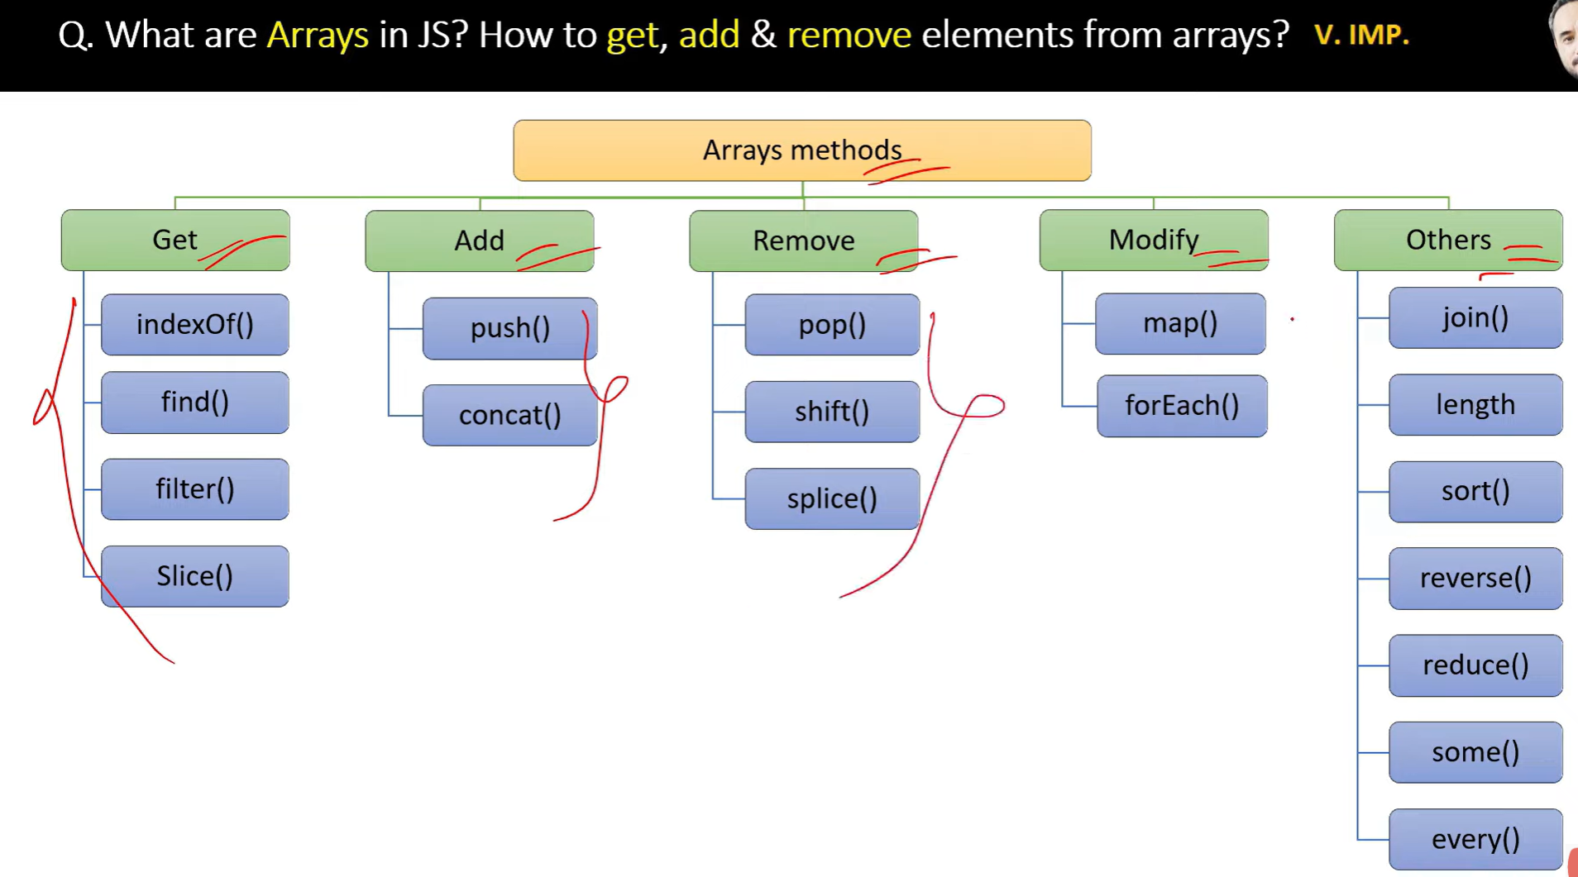

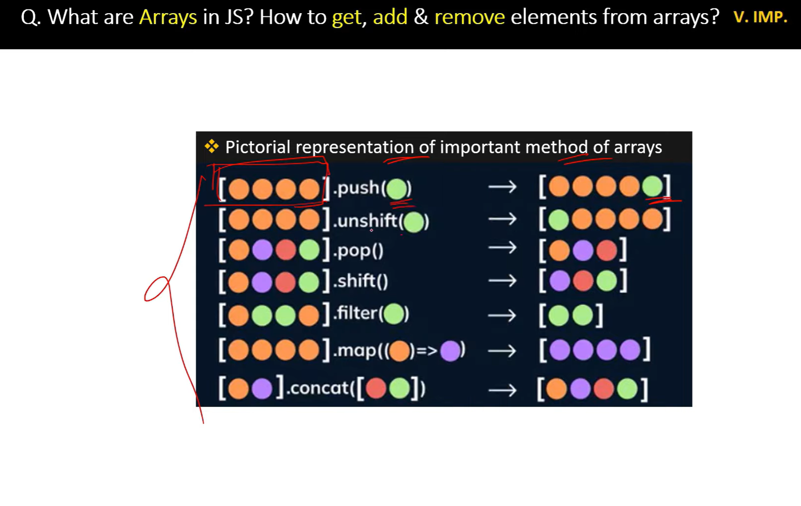

// map returns Array and also can chain with next method like filter, etc

// foreach doesnt return array but modifies the existing array.Also cannot chain

//=================Polifill of map====================

// creating own map function

Array.prototype.royMap= function(callback){

    let data=[];

    for(let i=0; i<this.length; i++){

        data.push(callback (this[i],i,this))

    }

    return data;

}

const mappedArray=[1,2,3].royMap((num,i,arr)=>{

    return num +3;

})

console.log(mappedArray) n

// creating own filter function

Array.prototype.RoyFilter = function (callback){

let data =[];

for(let i=0;i<this.length; i++){

if(callback(this[i],i,this)){

data.push(this[i])

}}

return data

}

const mappedList=[1,2,3].RoyFilter((item,i)=>{

return item > 2

})

console.log(mappedList) // 3

// creating own reduce function

Array.prototype.royReduce = function (callback, initialValue) {

let accumulator = initialValue !== undefined ? initialValue : this[0];

let startIndex = initialValue !== undefined ? 0 : 1;

for (let i = startIndex; i < this.length; i++) {

accumulator = callback(accumulator, this[i], i, this);

}

return accumulator;

};

const reducedValue = [1, 2, 3, 4].royReduce((acc, num) => acc + num, 0);

console.log(reducedValue); // Output: 10

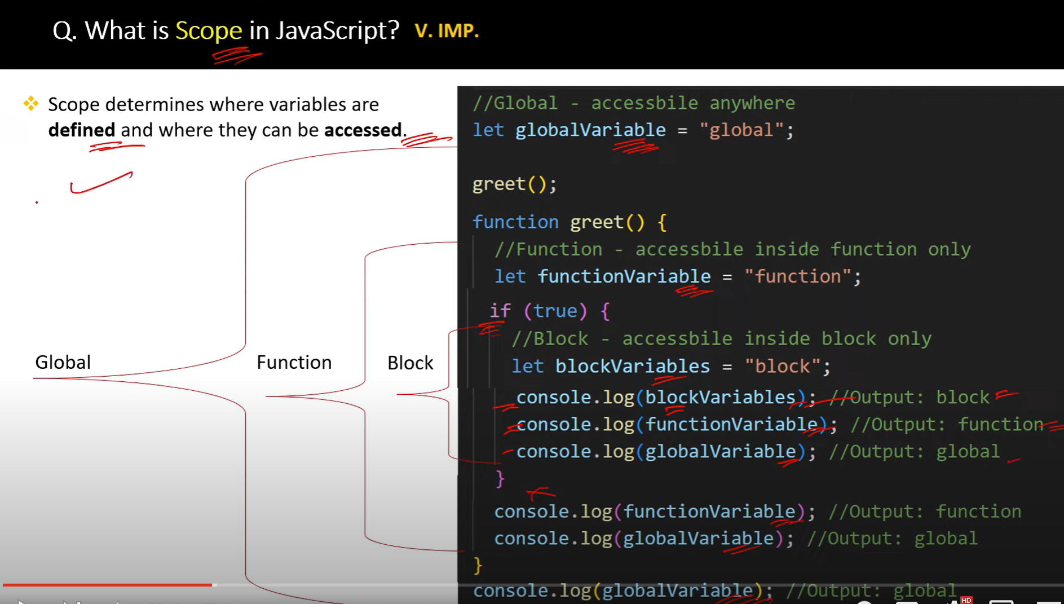

**closure** is a function that retains access to the variables from its **outer scope** even after the outer function has returned.

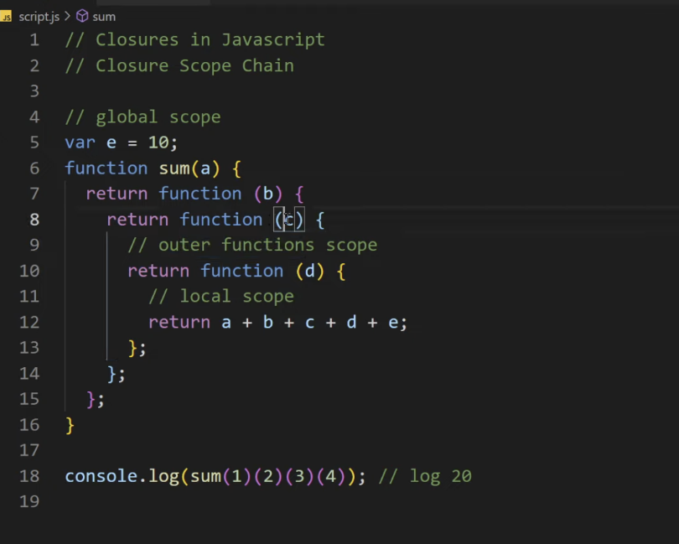

function outer() {

   let outerVar = "Hello";

   function inner() {

       console.log(outerVar);  // The inner function has access to `outerVar`

   }

   return inner;

}

const closureFunc = outer();  // outer() returns the inner function

closureFunc();  // Output: "Hello"

A closure is a function that "remembers" the environment in which it was created, even after the outer function has finished executing. This means the inner function has access to variables from its outer (enclosing) scope, even after the outer function has returned.

Key Characteristics of Closure:

Access to Outer Variables: A closure allows an inner function to access variables from its outer function even after the outer function has finished executing.

Private State: It can be used to create private variables and maintain state across function calls.

Function + Lexical Scope: The closure is created when a function is defined within another function, and it has access to variables in the outer function's scope.

Example of Closure:

javascript

Copy

Edit

function outer() {

let count = 0; // This is a private variable

return function inner() {

count++;

console.log(count);

};

}

const counter = outer();

counter(); // 1

counter(); // 2

counter(); // 3

In this example:

* The inner() function is defined within the outer() function.
* Even though outer() finishes executing when it returns inner(), the returned closureFunc still has access to the variable outerVar from the outer() function’s scope. This happens due to the closure.

**Currying** in JavaScript is a technique of transforming a function that takes multiple arguments into a sequence of functions that each take a single argument. In simple terms, currying allows you to break down a function with multiple parameters into a series of nested functions, each of which takes one argument and returns another function until all arguments are provided.

**Why Use Currying?**

Currying is useful for:

1. **Reusability**: It allows creating new functions by partially applying some of the arguments.
2. **Function Composition**: Curried functions can be easily composed with other functions to build more complex behavior.
3. **Delaying Execution**: Currying allows you to defer the execution of a function until all arguments are provided.

// Currying

1. function add(a) {
2. return function(b) {
3. return a + b;
4. };
5. }
6. const addTwo = add(2);  // Returns a new function that adds 2
7. console.log(addTwo(3));  // Output: 5
8. console.log(add(2)(3));  // Output: 5

// with arrow

const curriedMultiply = a => b => c => a * b * c;

const result = curriedMultiply(2)(3)(4); // 2 * 3 * 4 = 24

console.log(result);

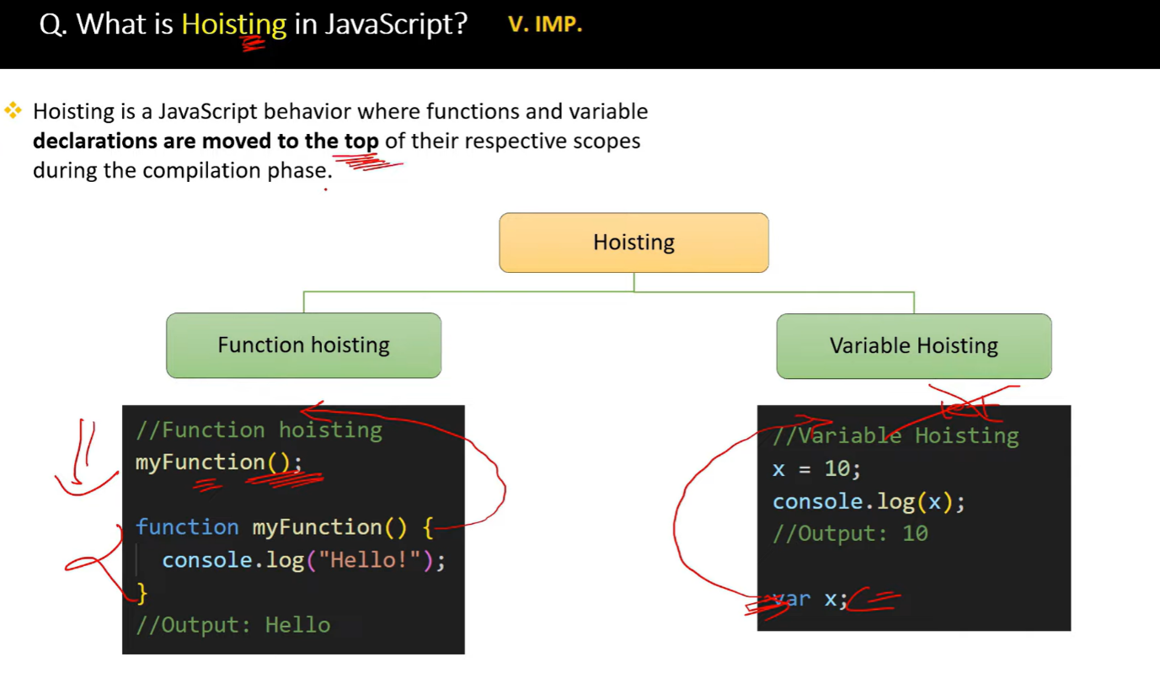

//===================Hoisting========================

function test() {

    console.log(a); // undeined

    console.log(b);  // not defined (temperial dead zone)

    console.log(c);  // not defined (temperial dead zone)

    var a = 6;

    let b = 7;

    const c = 9;

    }

    test();

//    Temporal Dead Zone refers to the period in the execution

    // of a JavaScript program where a variable exists but cannot be accessed.

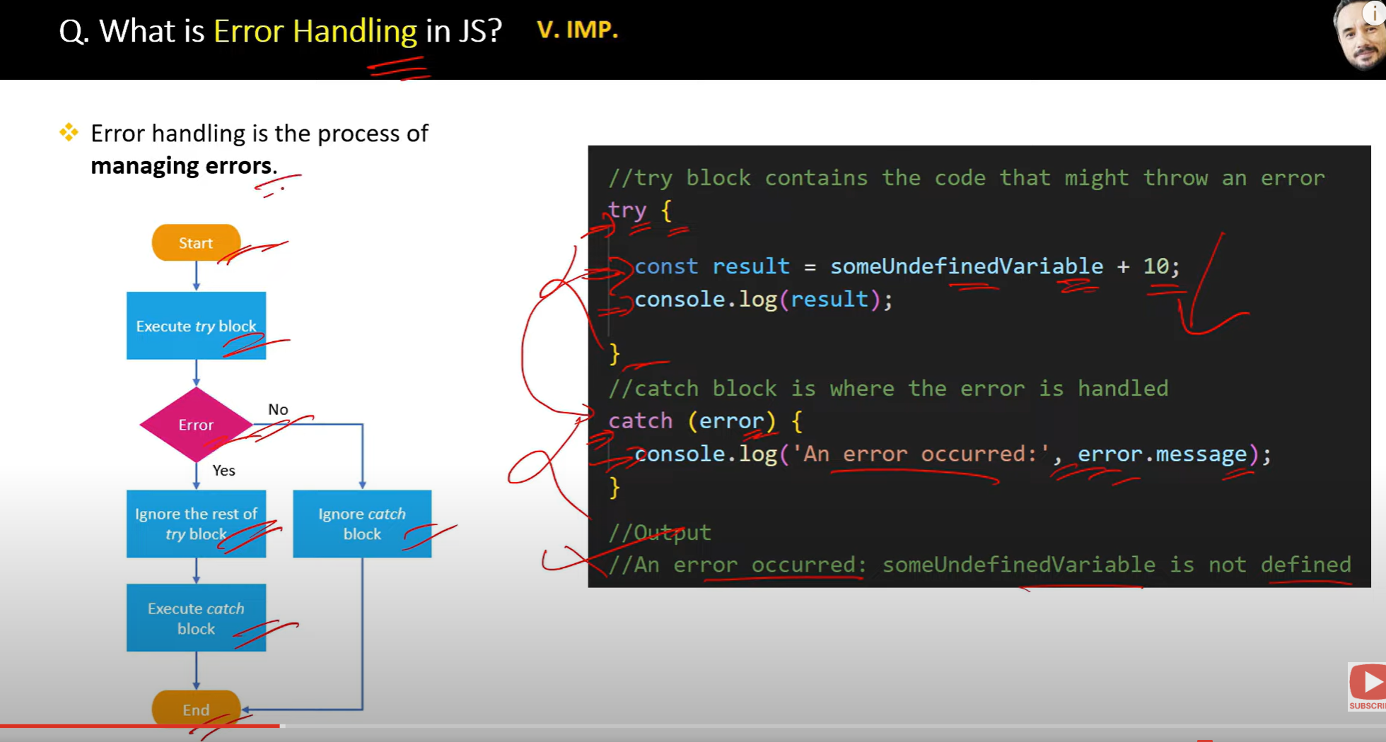

**CALL APPLY BIND**

Call method

**The call() method invokes a function immediately and allows you to specify the this value and pass individual arguments to the function.(obj, arg1, arg2, …)**

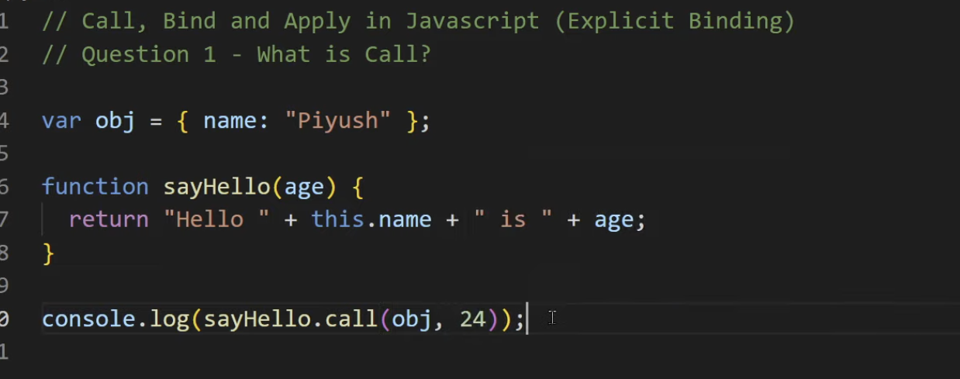

Apply

he apply() method is similar to call(), but instead of passing arguments individually, you pass them as an **array**. It also invokes the function immediately.

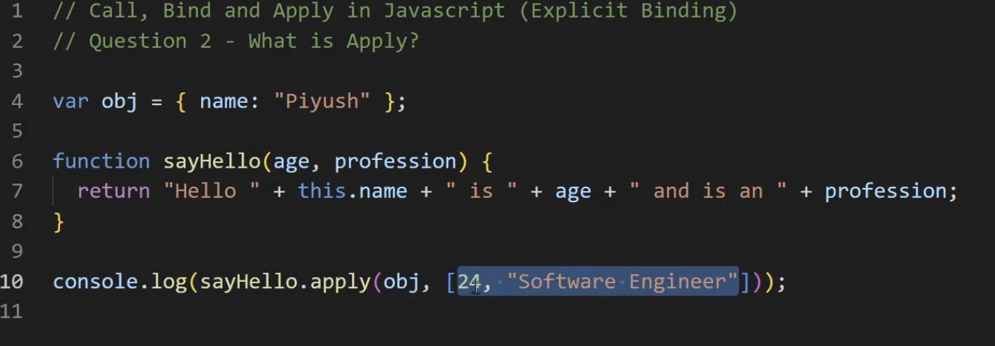

Bind (Resuable function) which in return another function

The bind() method does **not invoke the function immediately**. Instead, it returns a **new function** with a specific this value and (optionally) initial arguments, which can be invoked later.

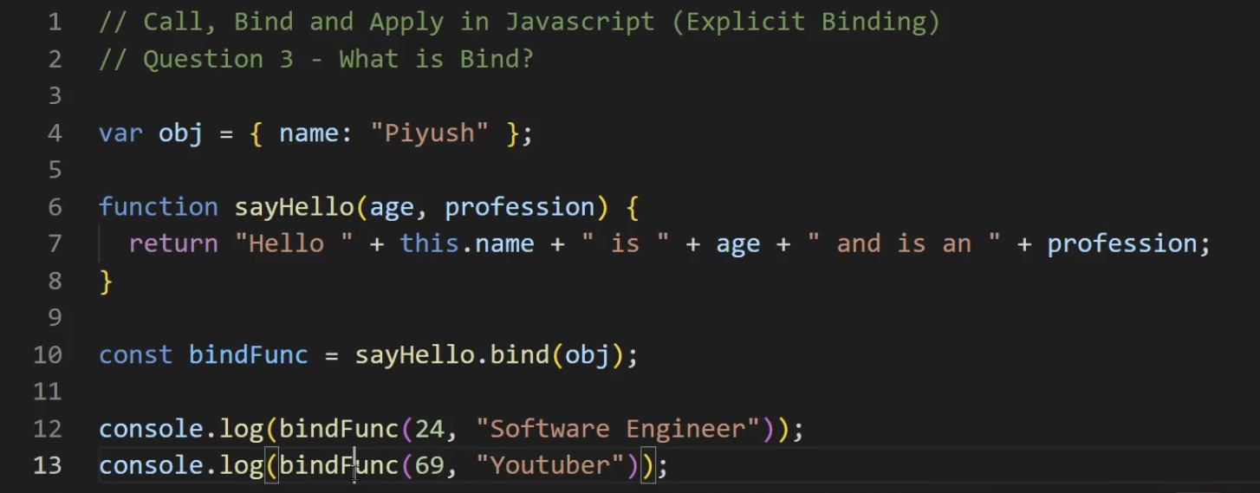

**Promise**

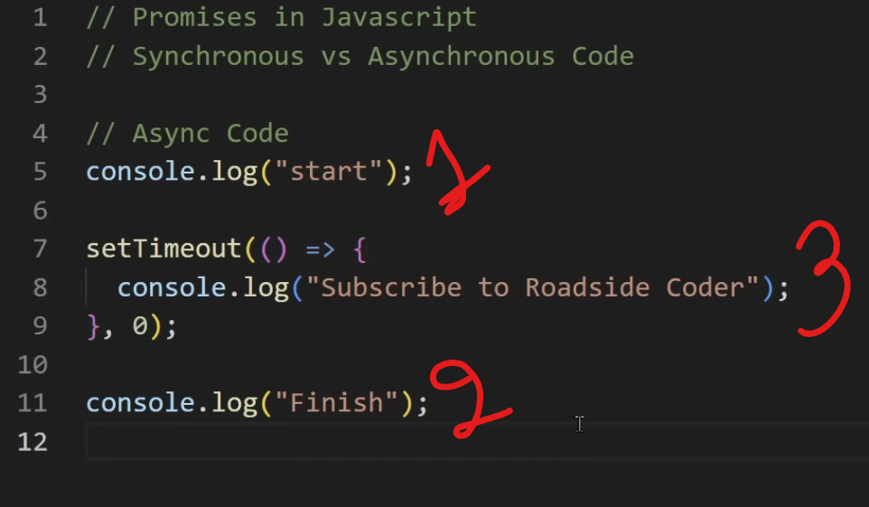

Callback hell nested callback

**Callback hell** refers to a situation in JavaScript (and other programming languages that use callbacks) where multiple nested callbacks lead to code that is difficult to read, maintain, and debug. It typically occurs in asynchronous programming when callbacks are used extensively, resulting in deeply nested structures that resemble a pyramid or "Christmas tree."

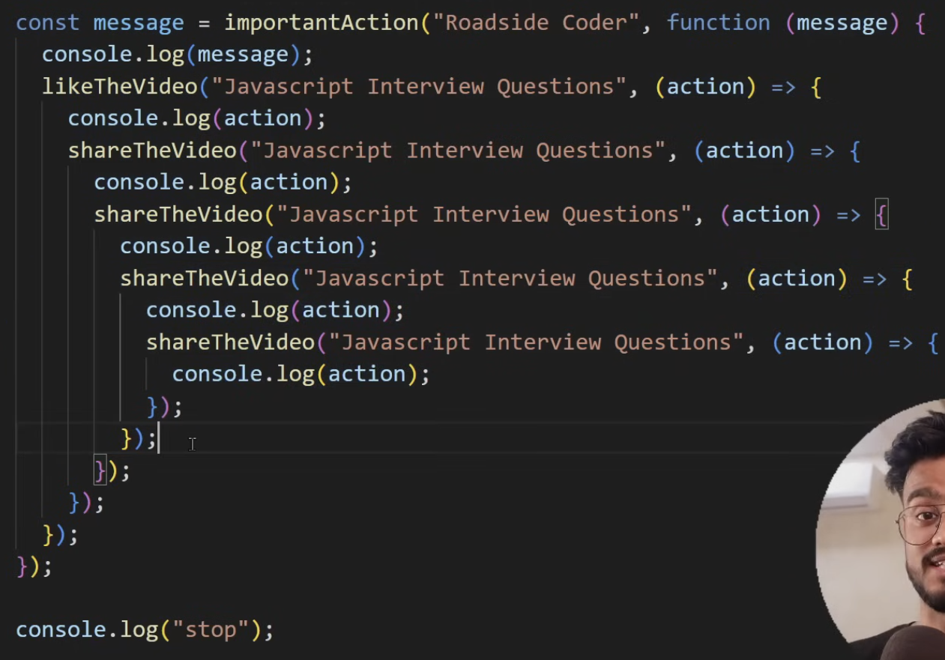

1. **Promises**: Use promises to handle asynchronous operations more cleanly, allowing for chaining and better error handling.
3. function performAsyncOperation() {
4. return new Promise((resolve, reject) => {
5. if(false){
6. return resolve({
7. hii:"hellow"
8. })
9. }else{
10. reject("Something went wrong.");
11. }
12. });
13. }
14. // Call the function and handle the Promise
15. performAsyncOperation()
16. .then(result => {
17. console.log(result); // Handle the resolved value
18. console.log("Operation completed");
19. })
20. .catch(error => {
21. console.error("Error:", error); // Handle any error
22. });**Async/Await**: Use async/await syntax for a more synchronous style of writing asynchronous code, which enhances readability.

javascript

async function performOperations() {

try {

const data = await getData();

const processedData = await processData(data);

const savedData = await saveData(processedData);

await sendConfirmation(savedData);

console.log("Operation completed");

} catch (error) {

console.error("Error:", error);

}

}

**Summary:**

* **Callback hell** makes code complex and difficult to manage due to excessive nesting of callbacks.
* Solutions include using modular functions, promises, or the async/await syntax to improve readability and maintainability.

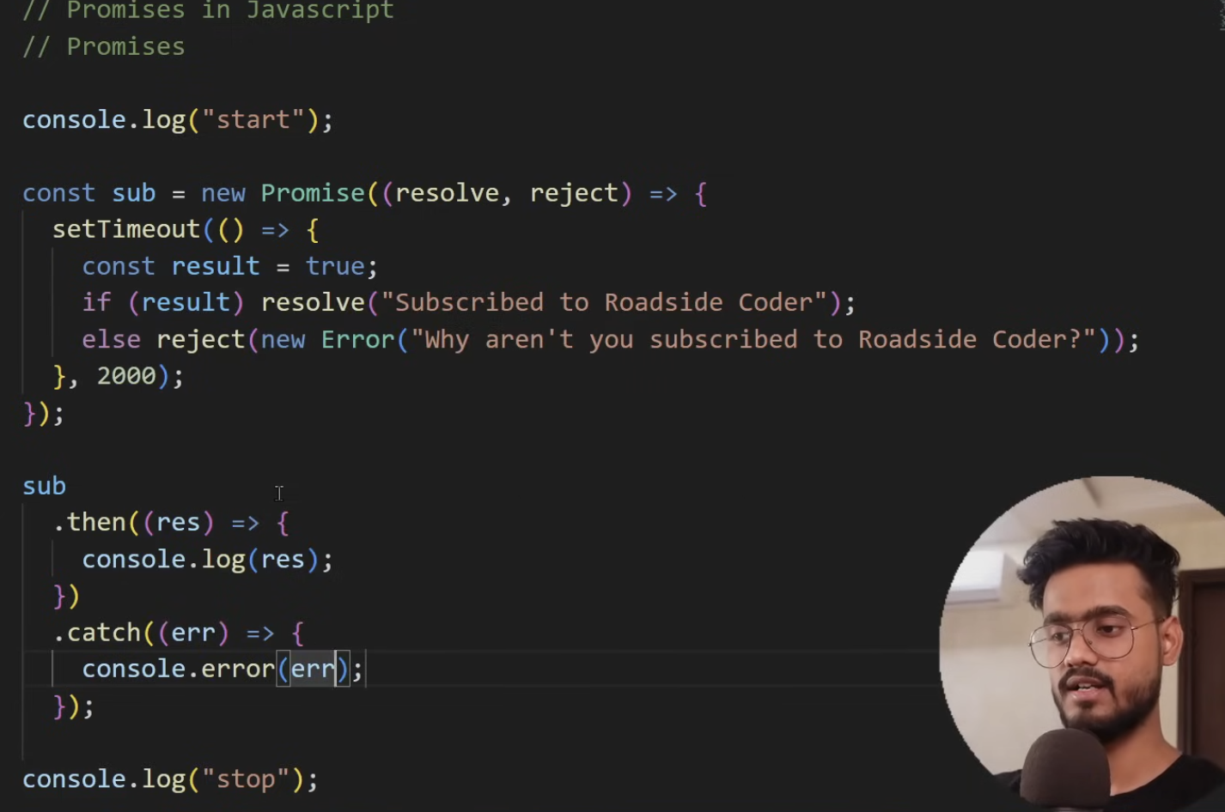

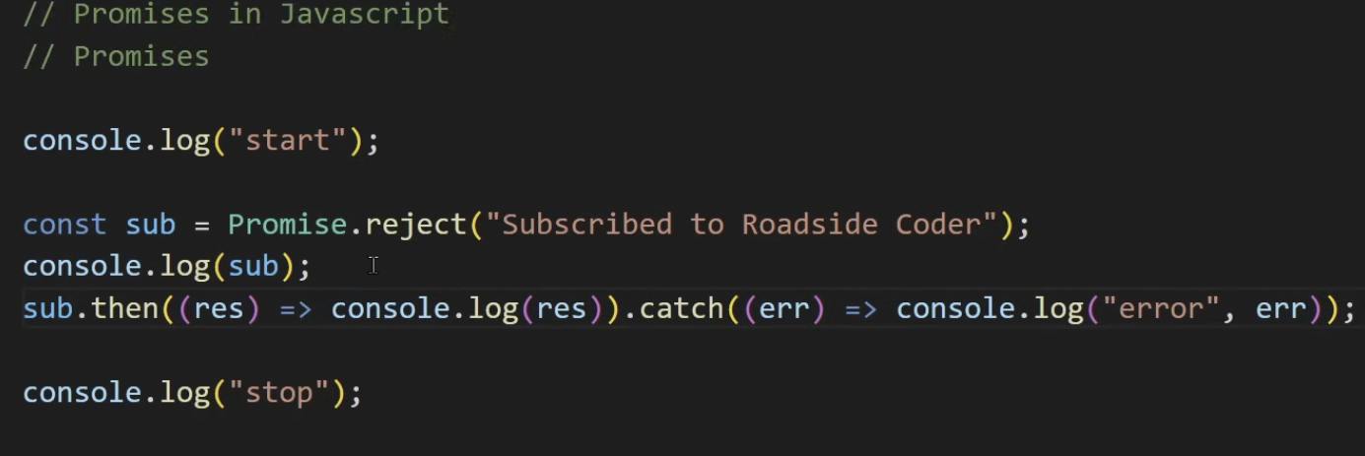

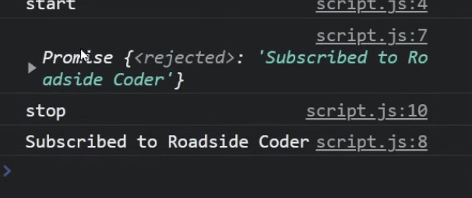

Promise.All => all should be resolved if one fails it wont execute

1. const promise1 = Promise.resolve(1);
2. const promise2 = Promise.resolve(2);
3. const promise3 = Promise.resolve(3);
4. Promise.all([promise1, promise2, promise3])
5. .then(results => { console.log('All promises resolved:', results); // [1, 2, 3] }) .catch(error => { console.error('One of the promises failed:', error); });

Promise.Race => Give any first promise resolved or failed

1. const promise1 = new Promise((resolve) => setTimeout(resolve, 2000, 'First'));
2. const promise2 = new Promise((resolve) => setTimeout(resolve, 1000, 'Second'));
3. Promise.race([promise1, promise2])
4. .then(result => { console.log('First settled:', result); // Second (because it resolves first) })
5. .catch(error => { console.error('Error:', error); });

Pomise.allSettled => takes an **array of promises** and returns a **single promise** that resolves when **all promises have settled**, **regardless of whether they are fulfilled or rejected**.

It never rejects. Instead, it **always resolves** with an array of **results**, where each result has:

1. const promise1 = Promise.resolve(1);
2. const promise2 = Promise.reject('Error occurred');
3. const promise3 = Promise.resolve(3);
4. Promise.allSettled([promise1, promise2, promise3])
5. .then(results => {
6. console.log('All promises settled:', results);
7. // Output:
8. // [
9. // { status: 'fulfilled', value: 1 },
10. // { status: 'rejected', reason: 'Error occurred' },
11. // { status: 'fulfilled', value: 3 }
12. // ]
13. });

Promise.any => first fulfilled promise and ignores all rejected ones

1. const promise1 = Promise.reject('First failed');
2. const promise2 = Promise.resolve('Second succeeded');
3. const promise3 = Promise.reject('Third failed');
4. Promise.any([promise1, promise2, promise3])
5. .then(result => {
6. console.log('First fulfilled promise:', result); // Second succeeded
7. })
8. .catch(error => {
9. console.error('All promises were rejected:', error);
10. });

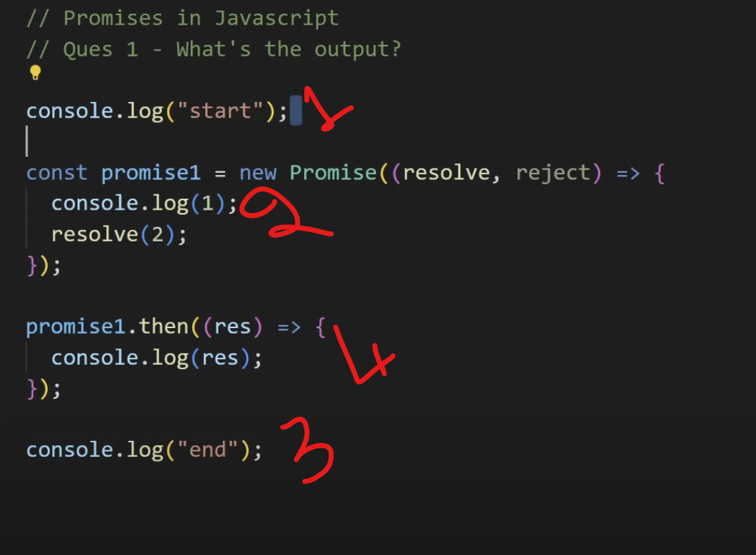

Debouncing => **Debouncing** is a technique used to **limit the number of times a function is executed**, especially for high-frequency events like typing , auto saving form data

// Debounce function using Lodash

const debouncedSearch = _.debounce((query) => {

  console.log("Searching for:", query);

}, 500);

// Simulating user typing

debouncedSearch("H");

debouncedSearch("He");

debouncedSearch("Hel");

debouncedSearch("Hell");

debouncedSearch("Hello"); // Only "Searching for: Hello" will be logged after 500ms of inactivity.

Throttling => is a technique that ensures a function is **executed at most once** in a specified **time interval**, **no matter how many times** the event is triggered. • Scroll event handlers

• Resize events

• Button spamming prevention

// Throttle function using Lodash

const throttledScroll = _.throttle(() => {

  console.log("Scroll position:", window.scrollY);

}, 1000); // Log scroll position every 1000ms

window.addEventListener("scroll", throttledScroll);

When you keep on clicking at add triggers in every 800 ms

**🔍 Difference Between Debounce and Throttle in JavaScript**

| **Feature** | **Debounce** | **Throttle** |
| --- | --- | --- |
| **🔁 Execution** | **Delays execution until after a pause in events** | **Executes at regular intervals during continuous events** |
| **⌛ Delay Behavior** | **Resets timer on each call — only runs once after user stops triggering** | **Runs once every X ms, regardless of how often the event is triggered** |
| **🧠 Use Case** | **Auto-suggest, live search, input validation, resizing (only once after done)** | **Scroll event, resize listener, rate-limited API calls** |
| **🔄 Cancels Calls** | **Yes — cancels the previous scheduled function call on each new event** | **No — runs periodically regardless of the new triggers** |
| **📦 Implementation** | **Uses setTimeout() and clearTimeout()** | **Uses timestamps or setTimeout() to manage intervals** |

**Event Bubling and event capturing**  
  
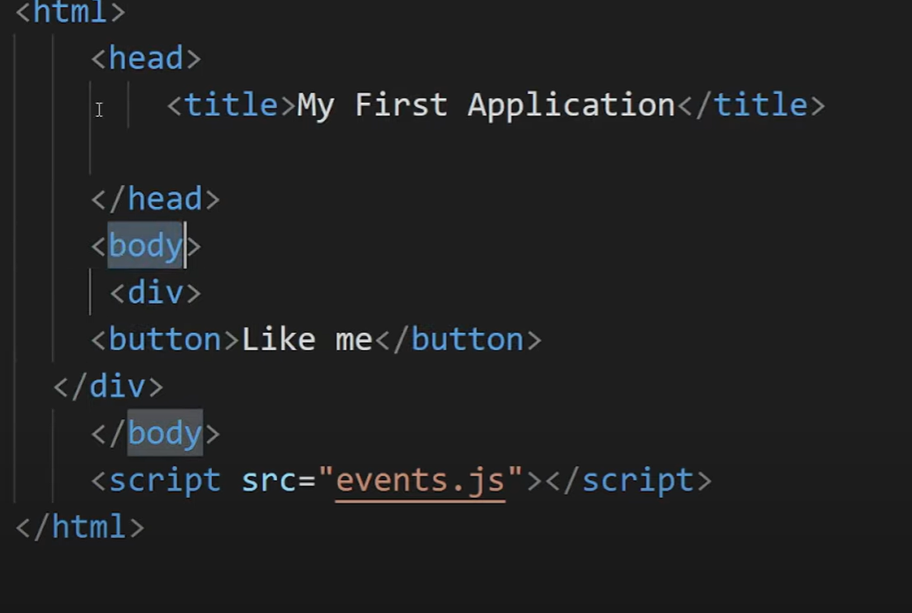

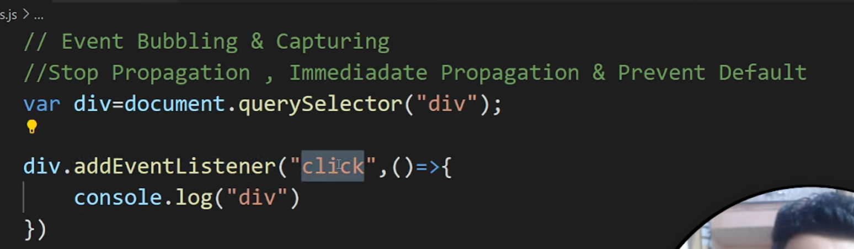

**Event bubbling** is a mechanism in JavaScript where an event starts from the **target element** and then propagates (or "bubbles up") to its **parent elements**. This continues until the event reaches the **document**.

**In above images div is printed when you click on button**

**event.stopPropagation() → stops bubbling**

const handleClick = (event) => {

  event.stopPropagation(); // ❌ Stop bubbling

  event.nativeEvent.stopImmediatePropagation(); // ❌ Stop capturing (React wraps native events)

  console.log("Only this runs.");

};

**if you have multiple event lister for button it will liston on button one and button2 and stops**

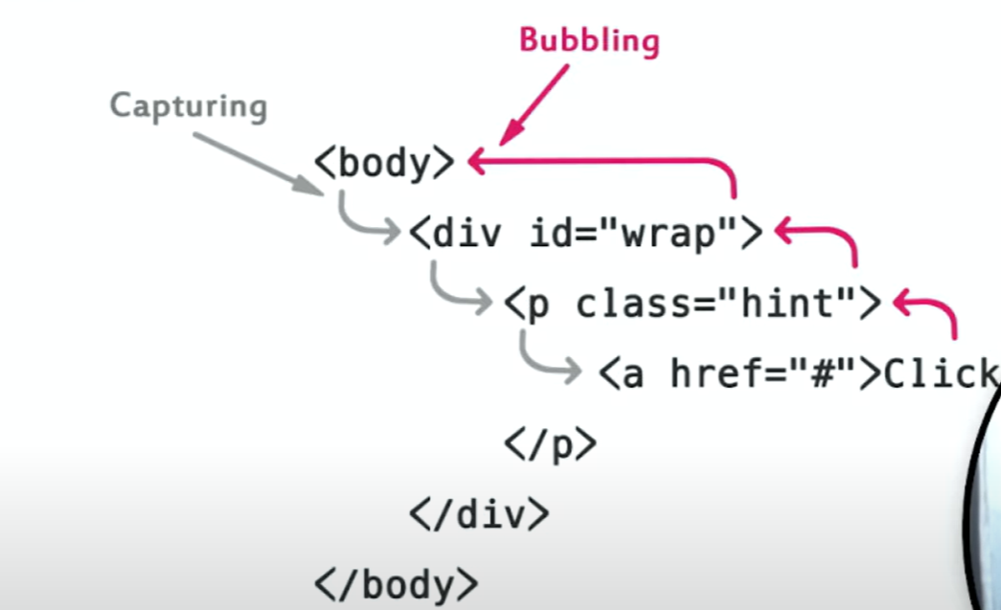

Event Loop

**Event Loop Explained for Non-Tech Person**

Imagine JavaScript as a **chef** in a kitchen. But this chef can only cook **one dish at a time** (single-threaded). So how does he manage cooking **many orders** without getting stuck?

**The Chef's Workflow:**

1. **To-Do List (Call Stack)** – This is the list of dishes the chef is working on **right now**.
2. **Waiters (Web APIs)** – These are helpers that handle **slow tasks** like timers or fetching data.
3. **Order Queue (Callback Queue)** – After the waiter is done, they place the dish here for the chef to finish.
4. **VIP Orders (Microtask Queue)** – These are important orders like “Promises” that go **ahead** of normal ones.
5. **Event Loop** – This is the **manager** who checks:
   * “Is the chef free?”
   * If yes, give the next VIP order.
   * If no VIPs, give a regular order from the queue.

**Summary:**

* **Chef** can only cook one dish at a time.
* **Slow tasks** are passed to waiters.
* **Manager (event loop)** brings finished tasks back to the chef.
* **VIP tasks (promises)** are served before others.